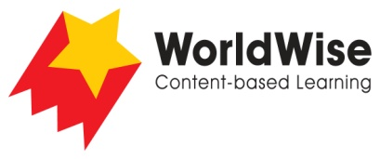

Grade 4 – Investigations
Don’t Throw It Away!

Part 3 - Record data
Find a way of recording your information that will allow you to see any patterns
in the data.
Change to suit your information!
 | In our homes | Outside our homes
What do we throw away?
Why do we throw these things away?
What is happening to places where we send our trash?
Which things are best reused?
Which things can be recycled?
What can we do to help?
What are organizations doing?
Once completed make sure you save this file

