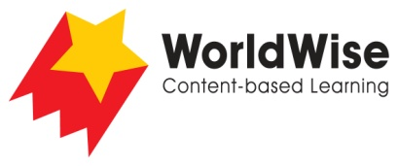

Grade 4 – Investigations
Don’t Throw It Away!

Part 5 – Present and share
Look over all the information that you have gathered in your investigation.
What are the most important ideas about your topic?
Make a chart showing the most important ideas.

 | Home trash | Neighborhood trash | City trash | Ocean trash
How is this trash created?
What harm does it do?
What environmental problems occur in these places?
How can this trash be reduced?
How is technology being used to assist in reducing trash?
How can we help?
Once completed make sure you save this file

