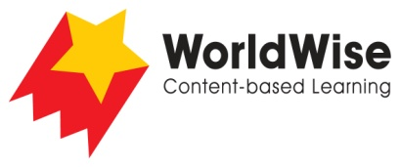

Grade 3 – Investigations
Finding Our Way
Part 5 – Present and share
Look over all of the information that you have gathered in your investigation.
What are the most important ideas about your investigation?
Make a chart showing the most important ideas.
How we improved our maps
Features | Zoo 1 | Zoo 2 | Museum 1 | Museum 2
Labels
Directions
Direction arrows
Icons to show where things are
Color coding
Icons to show where things are
Entrances and exits
Other

Once completed make sure you save this file.

